Inverted Pendulum Analysis

Control Report

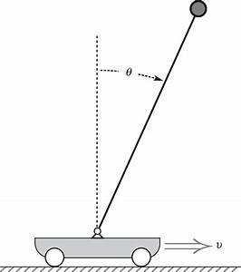

# 

# **Team Members**

|  |  |
| --- | --- |
| Aya Alzahy |  |
| Alaa Hesham Mahmoud | 201500638 |
| Waleed Mustafa | 201501346 |
|  |  |

1 | Introduction

|  |
| --- |
| **Overview** |

Inverted pendulum is a common problem in control systems. Its popularity comes from that it is unstable without control. It will fall over a cart carrying it unless the cart is moving to balance it. The objective of control is to apply certain amount of force on the cart to make the inverted pendulum be balanced. Although Inverted pendulum control is an old and challenging problem which quite often serves as a test-bed for a broad range of engineering applications. It is a classic problem in dynamics and control theory and widely used as benchmark for testing control algorithms (PID controllers, neural networks, fuzzy control, genetic algorithms, etc). One of the significant applications of Inverted pendulum is that it simulates robotic arm when the center of pressure lies below the center of gravity because this system is also unstable. Also, self-balancing robots are essentially inverted pendulum. To be able to analyze system, we first need to drive its transfer function then proceed to root locus analysis and frequency domain analysis

2 | Model derivation

|  |
| --- |
|  |

Here is the system:



We then draw a separate FBD for both the pendulum and the cart:

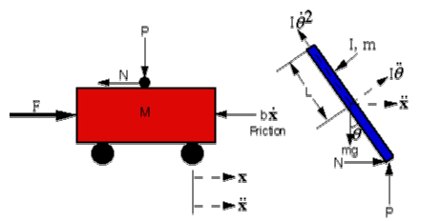

**From Cart FBD:**

Summing the forces in the Free Body Diagram of the cart in the horizontal direction, we get the following equation of motion:

**Equation [1]**



The force exerted in the horizontal direction due to the moment on the pendulum is:

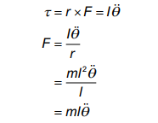

The component of the centripetal force acting along the horizontal axis is as follows:

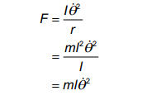

Summing the forces in the Free Body Diagram of the pendulum in the horizontal

direction, you can get an equation for N:

**Equation [2]**



In the following Analysis, we design PID controllers for the System with the following input:  
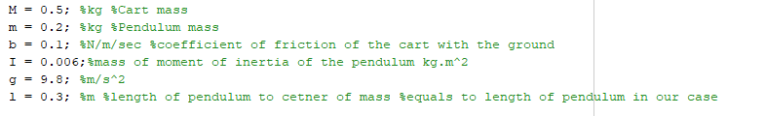

3| Analysis using root locus

|  |
| --- |
|  |

**Design Criteria:**

▪ Settling time of less than 5 seconds.  
▪ Pendulum should not move more than 0.05 radians away from the vertical.  
  
**I.** **Pendulum Angle**

**Root Locus Sketches**

**1- Uncompensated System**   
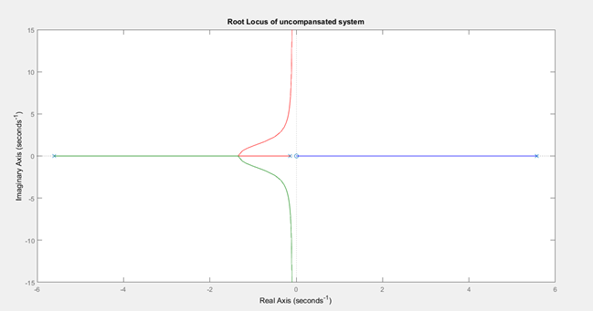

• The right-half-plane branch implies that a closed-loop pole will always be in the right half plane and the system

will be unstable.

• One solution is to add a pole to cancel the zero at the origin.

**2- System with Integrator**

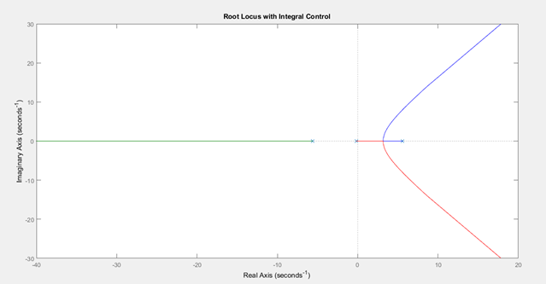

• We still have branches in the right-half plane, so we need to draw the poles into the left-half plane.

• One way is to design a PID controller after examining the location of the poles of the open-loop system.

● Location of open-loop poles and zeros:   
Pole location Zero location

|  |  |
| --- | --- |
| Pole location | Zero location |
| 0 | 0 |
| 5.5651 |  |
| -5.6041 |  |
| -0.1428 |  |

Adding two zeros between the left-half-plane poles, the right-half-plane poles will terminate at these zeros, and thus be pulled to the left.

**3- System with PID Controller**

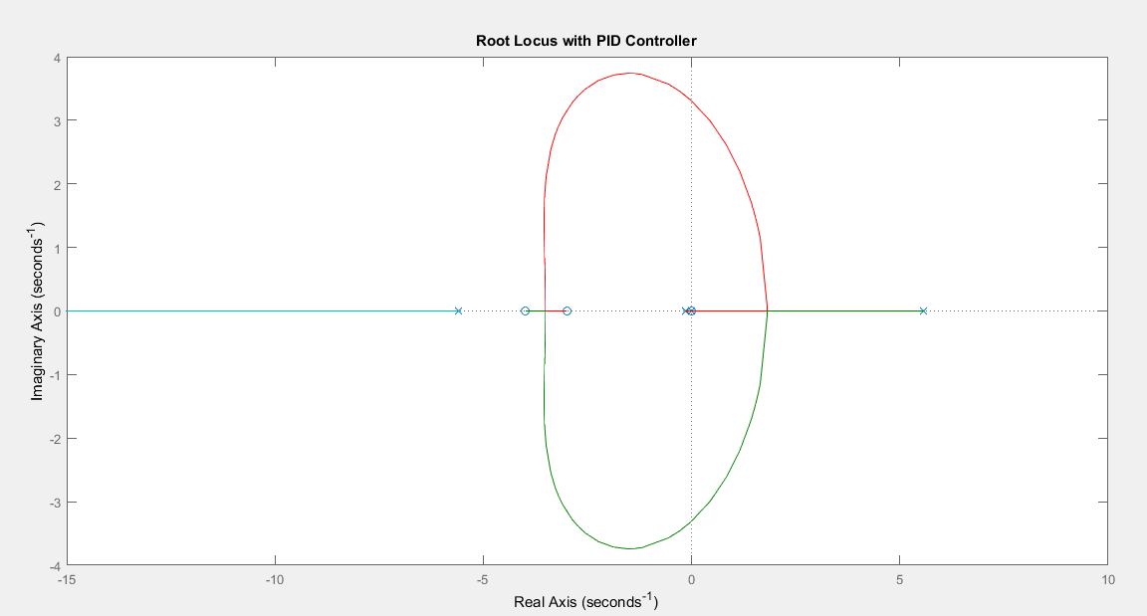

• As we increase the gain, the right-half plane poles of the closed-loop system should move to the left.

**Choosing a point on the root locus that satisfies the design criteria (to the left of -0.8 because point position=4/settling time)**  
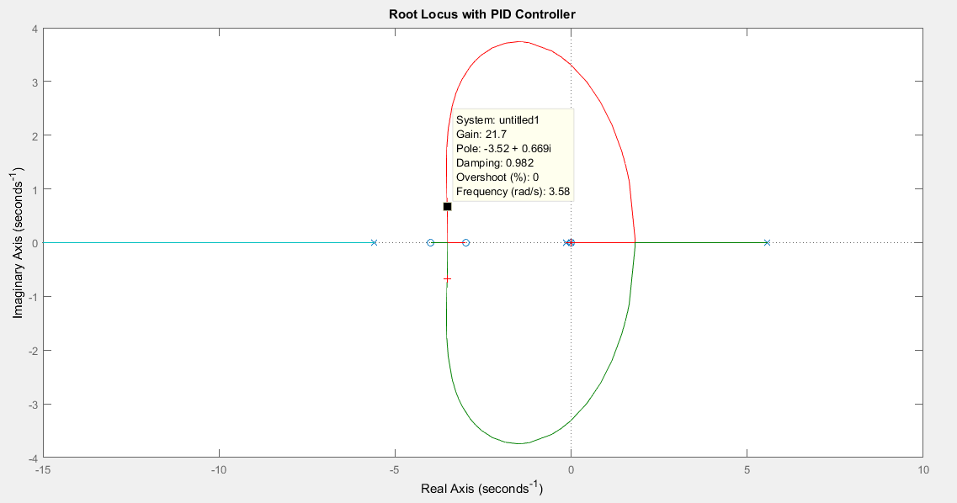

• Point gain= 21.7

**Closed-loop root locus for a gain of 21.7**

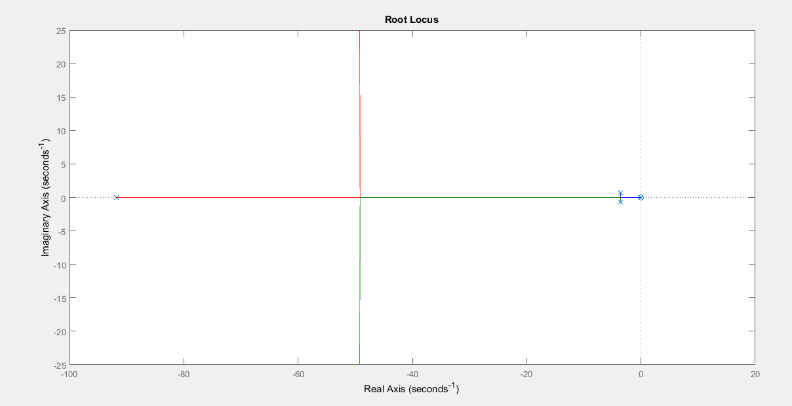

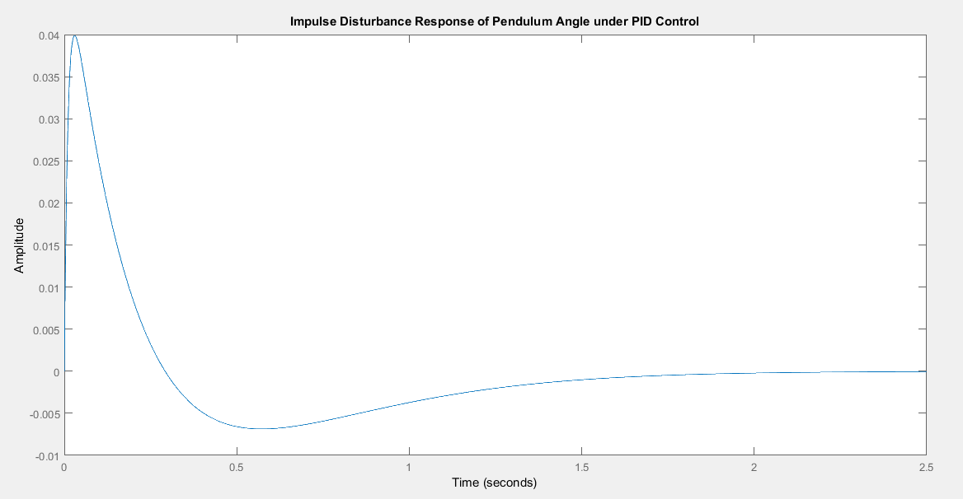  
• The system is stable since there are no right-half plane poles.

**II. Cart Position**

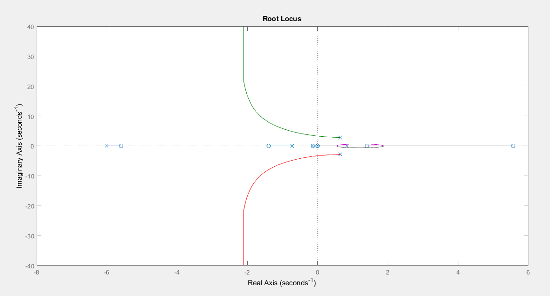  
  
• The closed loop system of cart position with PID controller is unstable since there are right-half-plane poles. Thus, the whole design is inapplicable.

4 | Frequency Domain Analysis

|  |
| --- |
|  |

Nyquist and Bode Plot of initial System:

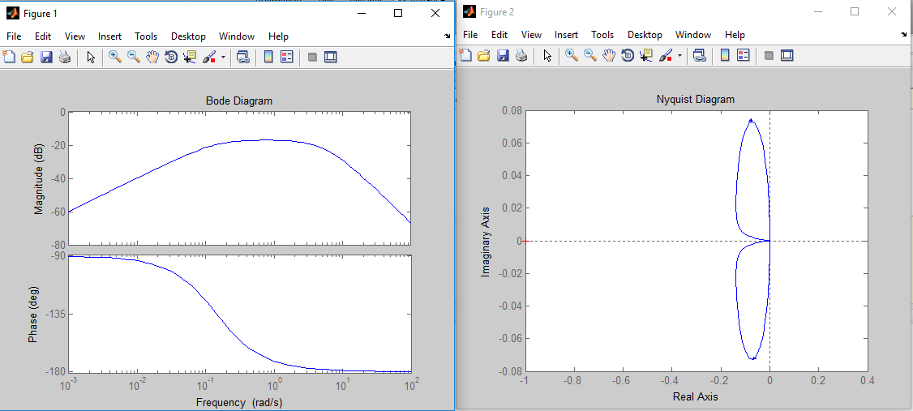

From ***zpkdata(P_pend),*** we know the system has one ***zero at the origin***, and three poles at ***5.5651 , -5.6041 , -0.1428.*** Therefore, while mapping the the right half plane, we have a zero inside our contour. For nyquist stability criterion, ***Z=P+N***, where ***Z***, the number of right half plane poles in the open loop system, should be zero. The ***P*** is the number of right half plane poles in the open loop system, and ***N*** is the number of clockwise encirclements of the ***-1*** point.

For our system, initially unstable, to have a state state error in the stable case, should at least be of type zero, for impulse response Steady State error to be zero. Therefore, we add an integrator (a pole at the origin), which cancels the zero at the origin, making the type of our system zero.  
For now, our open loop response is: ***G(s)*1/s***The plots thus changes to be:  
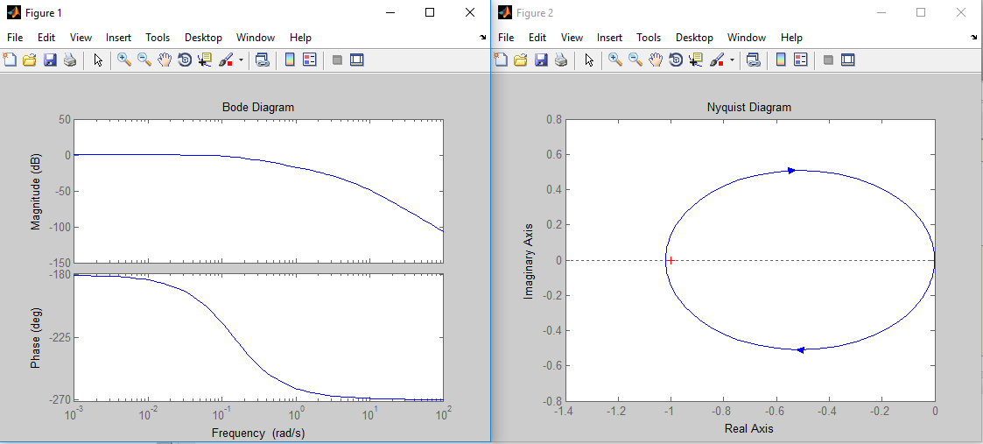

Now, after adding a pole, the Nyquist plot is shown to encircle the ***-1*** in the clockwise direction, which does not help with our Nyquist criteria, since the number of Close loop right half plane poles grows to equal ***2 (Z=P+N=1+1=2).***   
  
We have two ways to think of “stabilizing” the system. We can get the first one by looking at the Bode Plot: We need the phase to be well above the -180-degree in the Phase plot at the point where the magnitude is ***1.***  The other way is to think of the fact that we need one counterclockwise rotation in the Nyquist plot, one which we can then adjust to encircle the ***-1*** point.  
The first method of thinking will lead us to place a single zero at first, since we need positive phase. A zero is place arbitrarily at -1, to be adjusted later on. The resulting Nyquist and Bode Plots are:

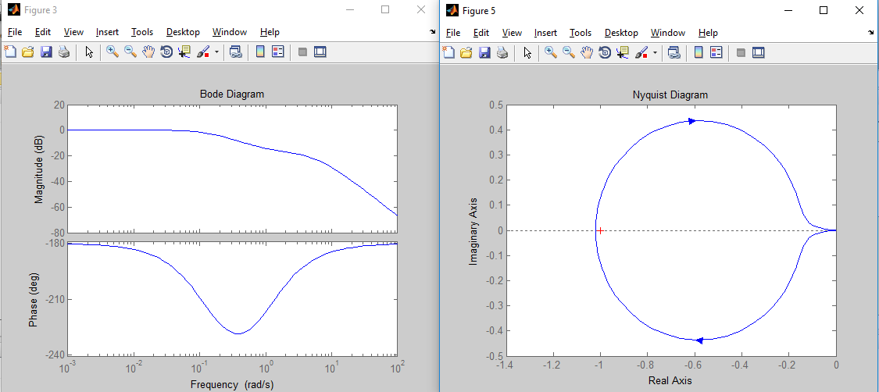

We clearly have more positive phase to add. We can see this from two points of view. First, from the Bode Plot point of view, we see that we haven’t surpassed the -180 phase, so our system remains unstable and we need more positive phase. Second, from the Nyquist plot, we see that we have still not formed a counterclockwise rotation in the contour. Therefore, we need one or more extra zeros. Upon adding an extra zero, again at s=***-1***,arbitrarily, we get the following Nyquist and Bode Plots:  
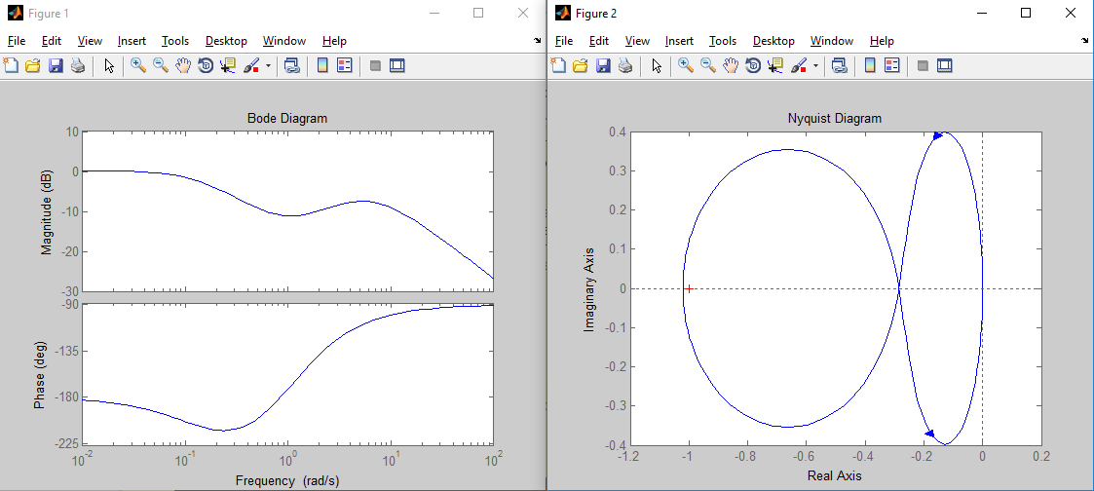  
  
  
We can see clearly from the Bode Plot that we can have a positive phase Margin only with gain compensation, since the phase surpasses -180 at a wide range of frequencies. We can also see that by looking at the Nyquist plot, as we now have a gain-adjustable counterclockwise loop.   
We could have seen that we needed one more zero (two zeros in total), from the very beginning, by looking a bit closer at the Nyquist plot, and noticing that we need a 360-degree rotation in the counterclockwise direction, which is achieved by adding two zeros.

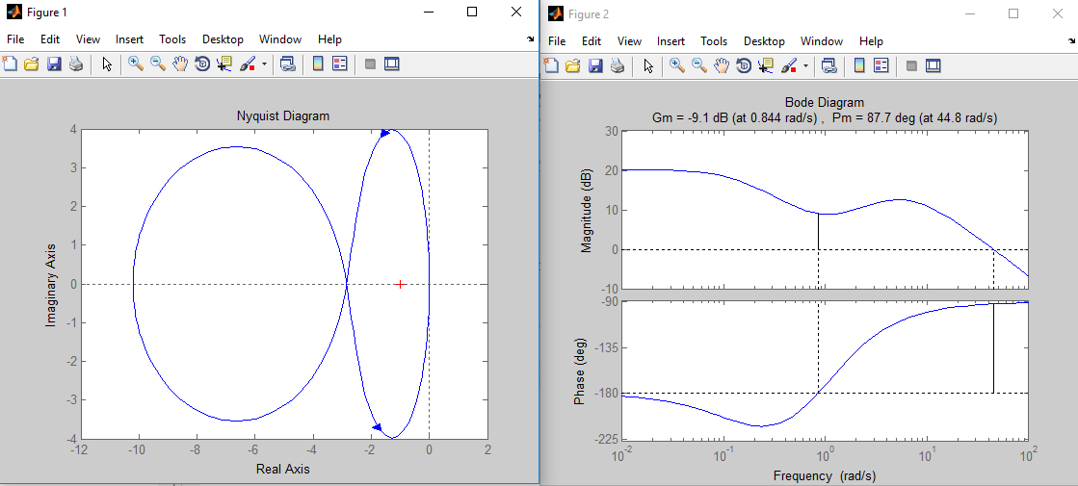

From trial and error, we see that a minimum gain of ***3.508*** to have a stable system, with gain margin = infinity. (***K>3.508***). A screenshot of the Nyquist and Bode Plots is taken at K=10 (arbitrary value). Which shows a controlled, stable system.

We can get the impulse response of the system by using the close loop system as an input to the function (impulse). We can adjust the gain and zeros positions to meet the desire overshoot and steady state error requirements.

Since we have no real Physical Constraints, I used zeros positions of **S=-1,-3 and gain = 50** to get a satisfying plot with respect to the mentioned parameters:

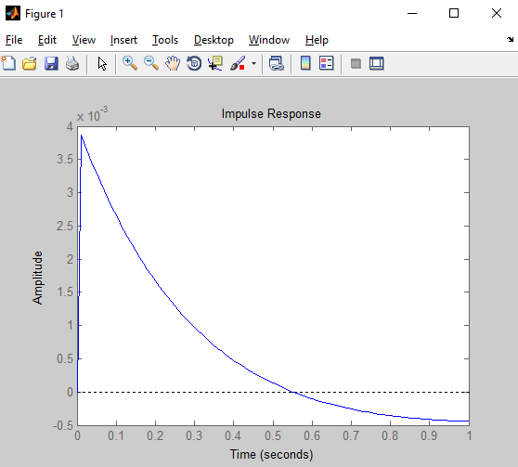

5 | References

|  |
| --- |
|  |

1: [System Modelling](http://ctms.engin.umich.edu/CTMS/index.php?example=InvertedPendulum&section=SystemModeling)

2: [Root Locus Analysis and Controller Design](http://ctms.engin.umich.edu/CTMS/index.php?example=InvertedPendulum&section=ControlRootLocus)

3: [Bode Plot and Nyquist Plot Analysis and Controller Design](http://ctms.engin.umich.edu/CTMS/index.php?example=InvertedPendulum&section=ControlFrequency)